LAB ASSIGNMENT 4 REPORT

MAHOUT CLASSIFICATION

As part of the lab 4 assignment I have done mahout classification. I have created my own data by taking the top 100 musics through wikipedia. I made a data file and arranged the data.

I have run the commands given in the tuorials. Below are the some of the screenshots of the outputs.

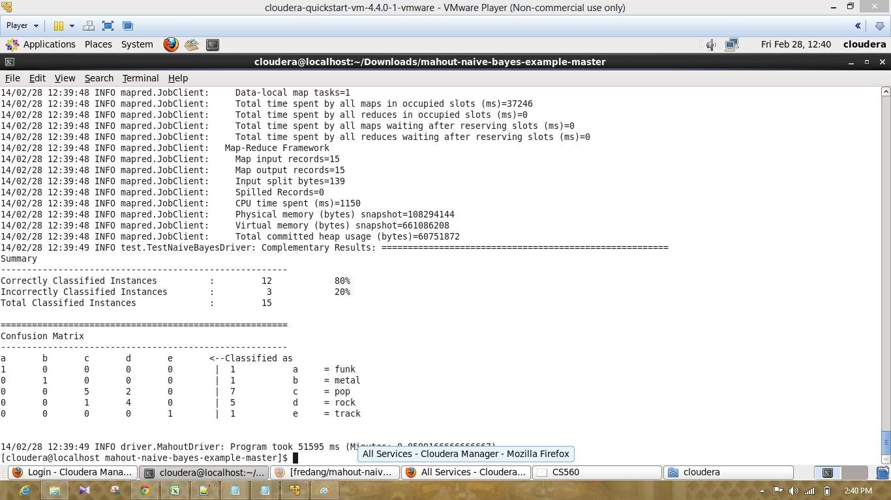

The above screenshot represents the confusion matrix obtained when I run the comand with the training vectors.

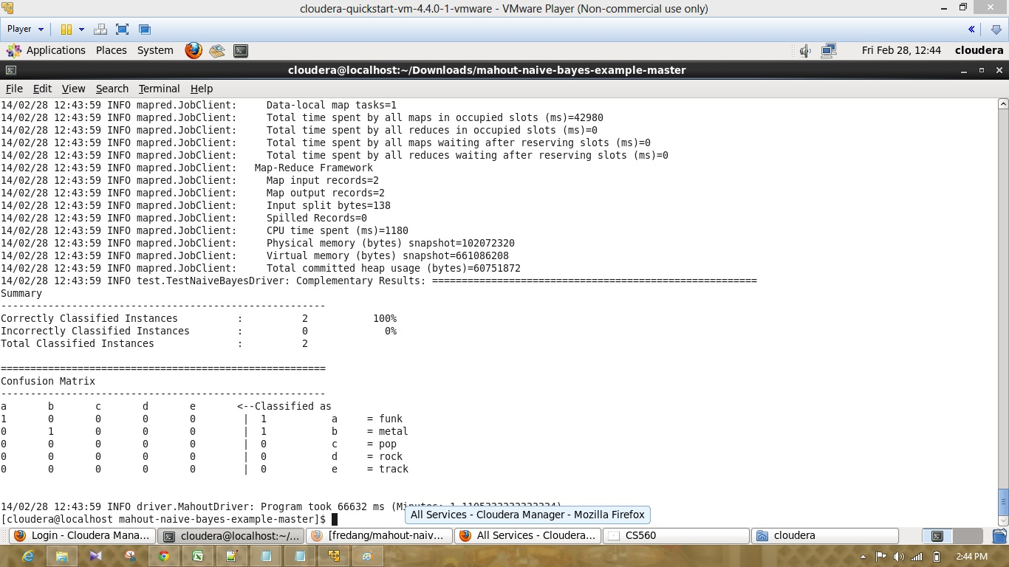

The above comand represents the confusion matrix obtained when the command run with the testing vectors.

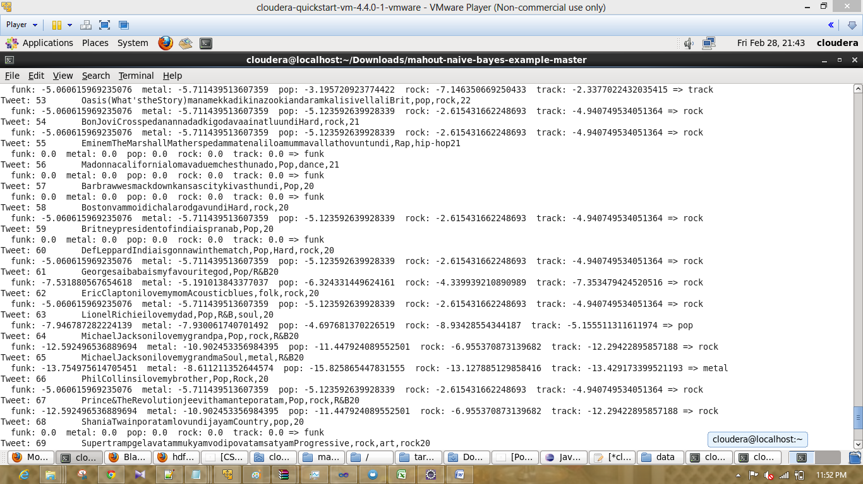

The above comand represents the mahout classification.

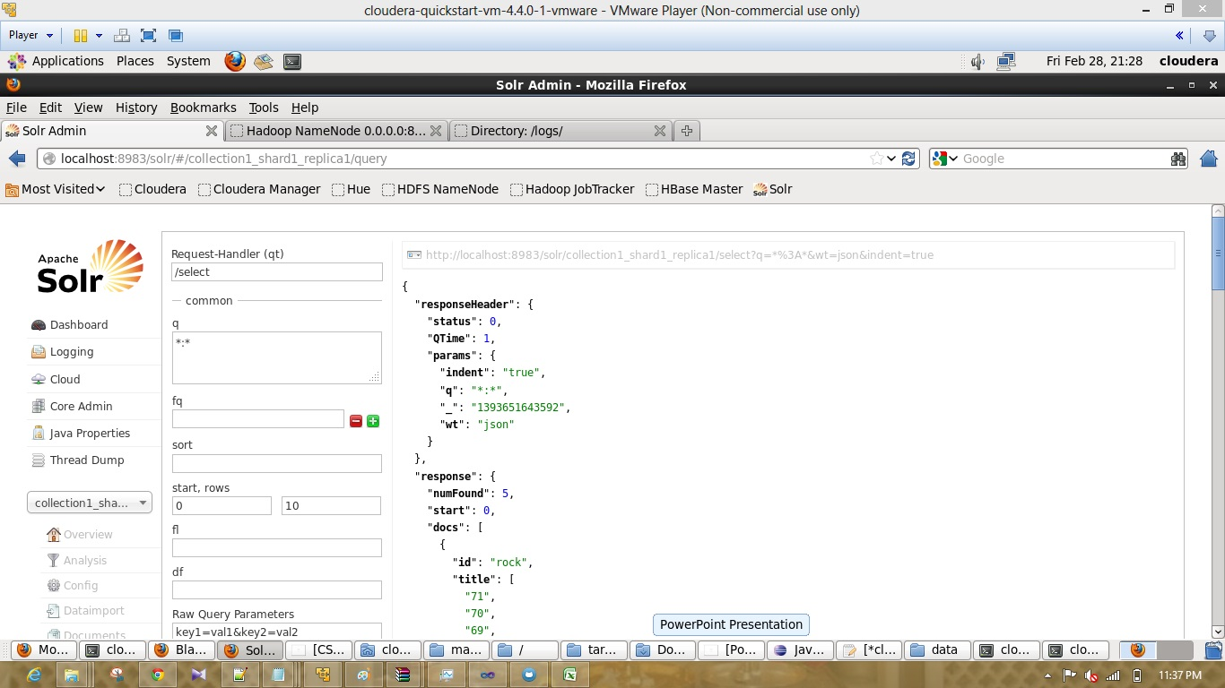

I have created the solr collection and pushed the data manually to solr. Screenshots represents the data pushed into solar

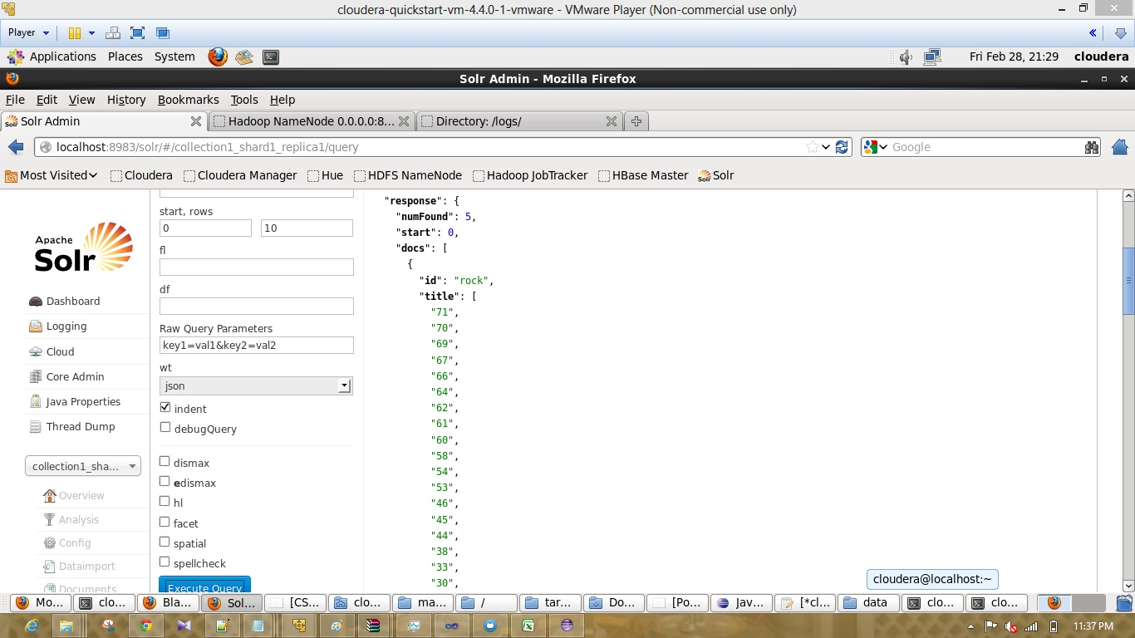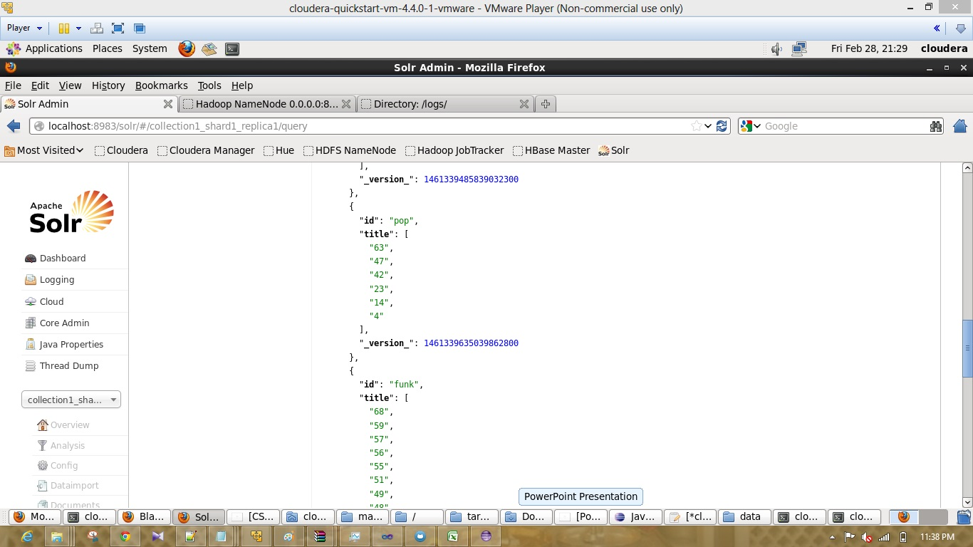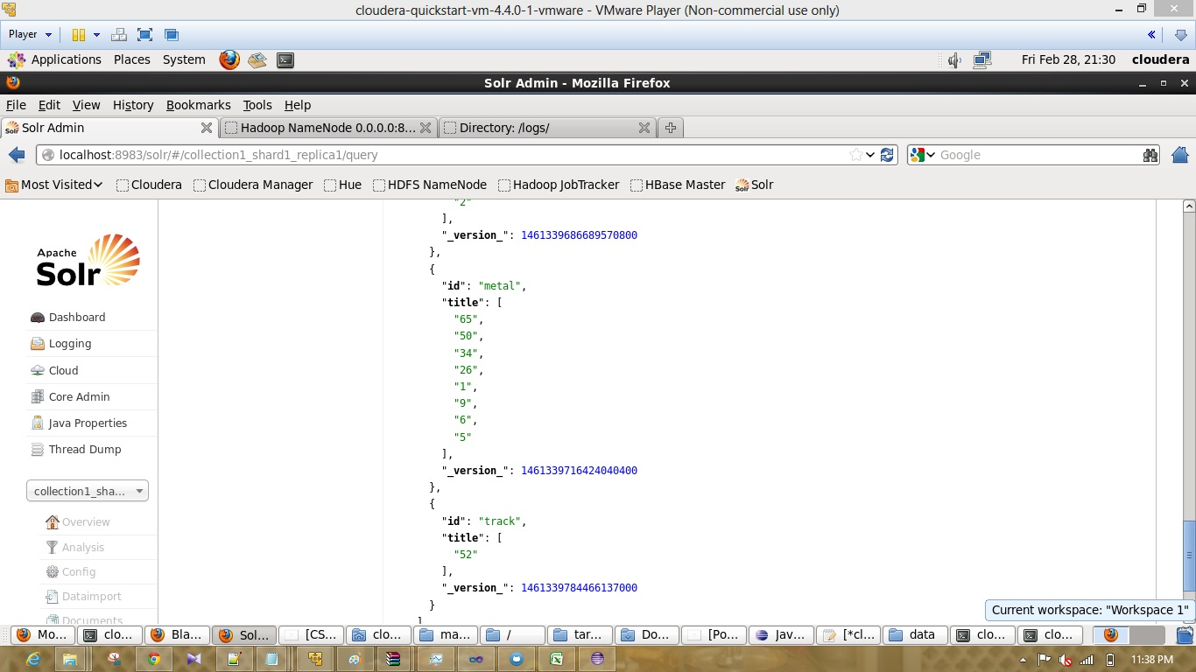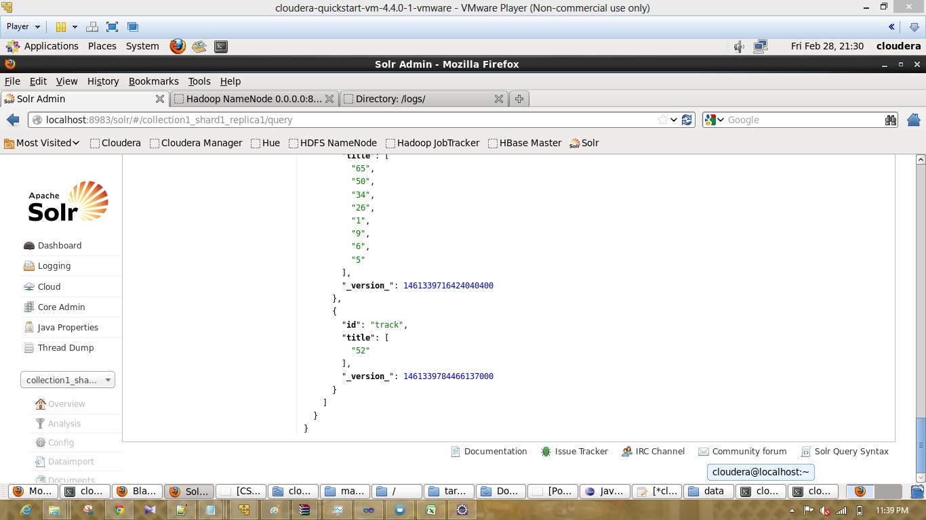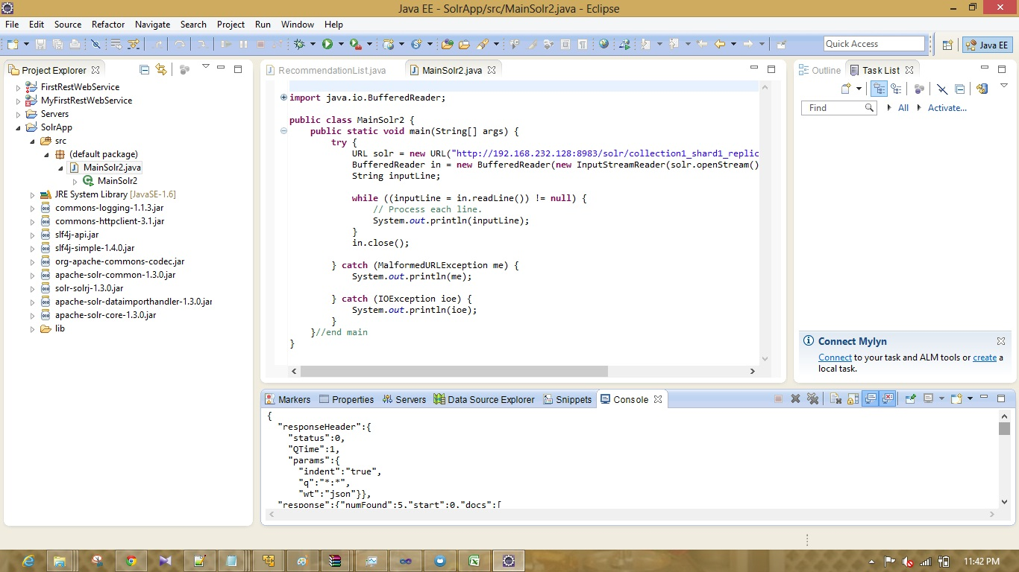

Then I used the solar app given with the tutorials and obtained the ouput in console.

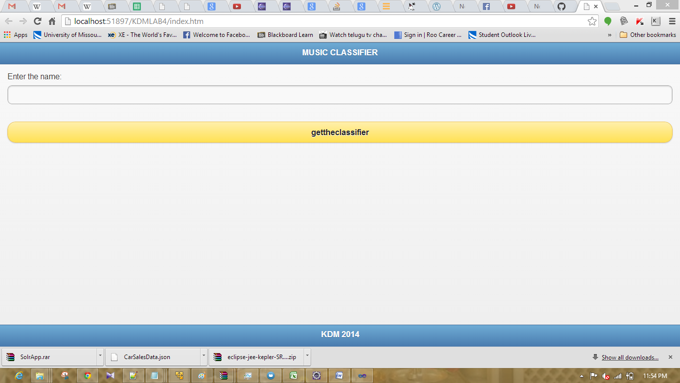

This will be the mobile app. I have experience errors while obtaining output. I hope I will try to execute it sucessfully and update the document.